**Project Design Phase-II**

**Data Flow Diagram & User Stories**

|  |  |
| --- | --- |
| Date | 03 October 2022 |
| Team ID | PNT2022TMID29999 |
| Project Name | Gas leakage monitoring and alerting system for industries |
| Maximum Marks | 4 Marks |

**Data Flow Diagrams:**

A Data Flow Diagram (DFD) is a traditional visual representation of the information flows within a system. A neat and clear DFD can depict the right amount of the system requirement graphically. It shows how data enters and leaves the system, what changes the information, and where data is stored.

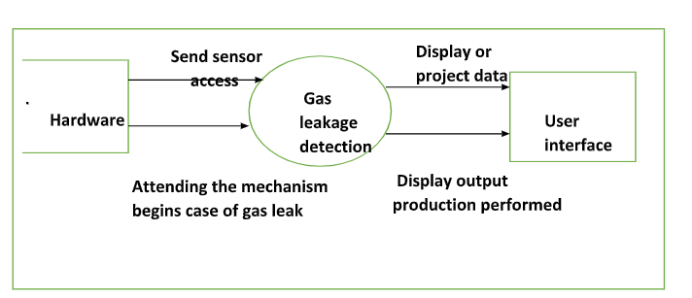**Example:** [**(Simplified)**](https://developer.ibm.com/patterns/visualize-unstructured-text/)

**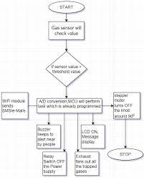   
 Level 0 : DFD**

**User Stories**

Use the below template to list all the user stories for the product.

| **User Type** | **Functional Requirement (Epic)** | **User Story Number** | **User Story / Task** | **Acceptance criteria** | **Priority** | **Release** |
| --- | --- | --- | --- | --- | --- | --- |
| Customer (Mobile user) | Registration | USN-1 | As a user, I can register for the application by entering my email, password, and confirming my password. | I can access my account / dashboard | High | Sprint-1 |
|  |  | USN-2 | As a user, I will receive confirmation email once I have registered for the application | I can receive confirmation email & click confirm | High | Sprint-1 |
|  |  | USN-3 | As a user, I can register for the application through Facebook | I can register & access the dashboard with Facebook Login | Low | Sprint-2 |
|  |  | USN-4 | As a user, I can register for the application through Gmail | I can register access the dashboard with the g-mail | Medium | Sprint-1 |
|  | Login | USN-5 | As a user, I can log into the application by entering email & password | I can register user and logged out, if I go to the login page and enter my user name and password and click on login then the data associate to my user should be accessible | High | Sprint-1 |
|  | Dashboard | USN-1 | As a user, I can register dashboard email or password | I can register password and click the login then log in fail with the error message that specifies that the username or password was wrong | High | Sprint-1 |
| Customer (Web user) | Login | USN-2 | As a user, I can register for the application through the g-mail | I can receive the application from the g-mail | High | Sprint-2 |
| Customer Care Executive | Registration | USN-3 | We have all needed help from a customer service executive at one time or another, sometimes its cell phone with garbled display or a lost or an urgent gas leakage. | I can register from the customer service executive the form of application | Medium | Sprint-1 |
| Administrator | Help desk | USN-4 | Agent to provide emergency step to customer | I can provide a emergency step to customer | Medium | Sprint-2 |
|  | Manage | USN-5 | Control centre failure response team turn off all ovens, open flames, and other potential, ignition sources. | I can provide a control centre failure response team turn off all ovens, open flames, and other potential, ignition sources | High | Sprint-1 |